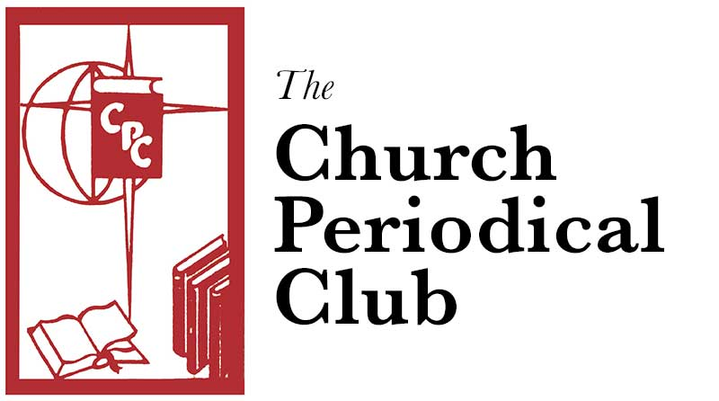

Serving God's People Through the Written Word

The Church Periodical Club is an Episcopal institution; its ministry is to make grants that supply written materials of any type free to those who cannot otherwise obtain them. All grants are funded through donations from individuals, churches, and organizations.

The National Books Fund makes grants that provide religious and secular written materials primarily for adults. The Miles of Pennies Fund provides grants for children birth through high school.
who c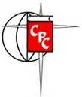
Church Periodical Club Prayer

Bless O Lord, The Church Periodical Club, that it may be an instrument for the spread of your Word throughout the world. Grant to its officers wisdom and patience, to its members perseverance and the spirit of sharing that asks no return. Bring more to take part in its mission and ministry. Bless our gifts and those who receive them, to the enrichment of individual lives, that we all may be servants of the risen Lord. Amen.

https://churchperiodical.com

Serving God's People Through the Written Word

The Church Periodical Club is an Episcopal institution; its ministry is to make grants that supply written materials of any type free to those who cannot otherwise obtain them. All grants are funded through donations from individuals, churches, and organizations.

The National Books Fund makes grants that provide religious and secular written materials primarily for adults. The Miles of Pennies Fund provides grants for children birth through high school.
who c
Church Periodical Club Prayer

Bless O Lord, The Church Periodical Club, that it may be an instrument for the spread of your Word throughout the world. Grant to its officers wisdom and patience, to its members perseverance and the spirit of sharing that asks no return. Bring more to take part in its mission and ministry. Bless our gifts and those who receive them, to the enrichment of individual lives, that we all may be servants of the risen Lord. Amen.

https://churchperiodical.com

