The CPC banner and full name:
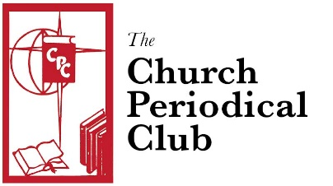

The CPC logo globe, cross and book with “CPC”:
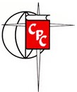

The CPC logo, full name and two descriptions:

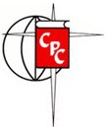
Church Periodical Club

Dedicated to the Ministry of the Written Word An affiliate of The Episcopal Church

The provincial and world maps on either side of the CPC logo:
